**CORRELATION ANALYSIS**

**Assignment Number 7**

Register Number: 1740256

**Date:** 28/08/2017

**Question 1**

**Aim** - To find correlation between 2 sets of data X and Y.

**Procedure** –

1. Draw a scatter plot along with the trend line to represent the data graphically.
2. Place the 2 data groups adjacent to each other.
3. Use the correl function as follows –

* Choose a blank cell and put =correl, open the bracket and enter the 2 groups of data by selecting them, close the bracket and press enter.

**Note**: If value is greater than 0.8, correlation is high. Between 0.5 and 0.8 is median and moderate. Less than 0.5, correlation is low.

**Calculations –**

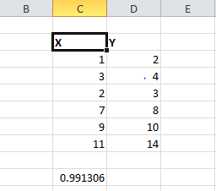 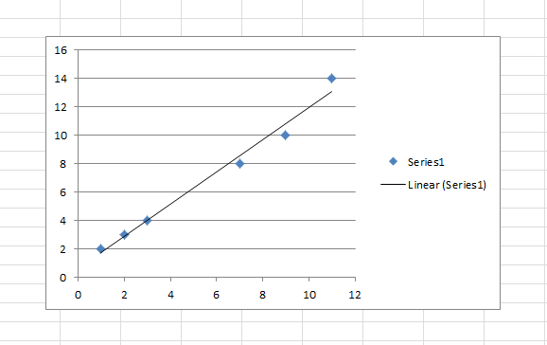

**Conclusion** –

The coefficient of correlation between X and Y is 0.991306 and has high degree of correlation.

---------------------------------------------------------------------------------------------------------------------

**Question 2**

**Aim** - To find correlation between 2 sets of data X and Y.

    a.  Sketch a scatterplot.

    b.  Compute the correlation coefficient, r.

**Procedure** –

* 1. Draw a scatter plot along with the trend line to represent the data graphically.
  2. Place the 2 data groups adjacent to each other.
  3. Use the correl function as follows –
* Choose a blank cell and put =correl, open the bracket and enter the 2 groups of data by selecting them, close the bracket and press enter.

**Note**: If value is greater than 0.8, correlation is high. Between 0.5 and 0.8 is median and moderate. Less than 0.5, correlation is low.

**Calculations –**

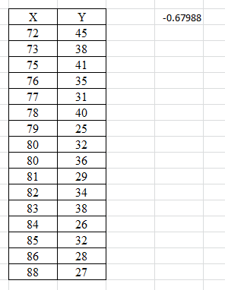 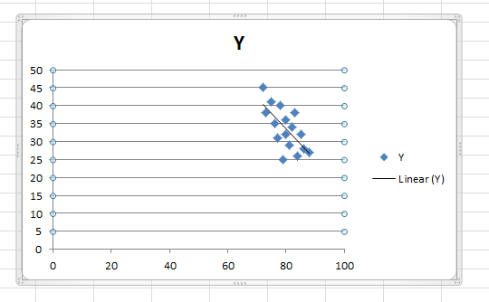

**Conclusion** –

The coefficient of correlation between X and Y is -0.67988 and has moderate degree of negative correlation.

**Question 3**

**Aim** - Calculate coefficient of Correlation between price and supply.

Interpret the value of correlation coefficient.

|  |  |  |  |  |  |  |  |  |
| --- | --- | --- | --- | --- | --- | --- | --- | --- |
| Price | 8 | 10 | 15 | 17 | 20 | 22 | 24 | 25 |
| Supply | 25 | 30 | 32 | 35 | 37 | 40 | 42 | 45 |
|  |  |  |  |  |  |  |  |  |

**Procedure** –

a. Draw a scatter plot along with the trend line to represent the data graphically.

1. Place the 2 data groups adjacent to each other.
2. Use the correl function as follows –

* Choose a blank cell and put =correl, open the bracket and enter the 2 groups of data by selecting them, close the bracket and press enter.

**Note**: If value is greater than 0.8, correlation is high. Between 0.5 and 0.8 is median and moderate. Less than 0.5, correlation is low.

**Calculations –**

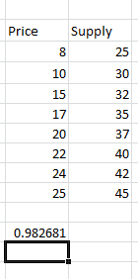 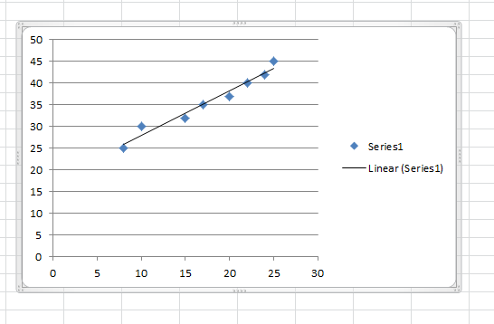

**Conclusion** –

The coefficient of correlation between price and supply is 0.982681 and has a high degree of correlation.

**Question 4**

**Aim** - Find out Karl Pearson’ s coefficient of correlation in the

Following series relating to prices and supply of a commodity.

|  |  |  |  |  |  |  |  |  |  |  |
| --- | --- | --- | --- | --- | --- | --- | --- | --- | --- | --- |
| Price(Rs.) | 11 | 12 | 13 | 14 | 15 | 16 | 17 | 18 | 19 | 20 |
| Supply(Rs.) | 30 | 29 | 29 | 25 | 24 | 24 | 24 | 21 | 18 | 15 |
|  |  |  |  |  |  |  |  |  |  |  |

**Procedure** –

* 1. Draw a scatter plot along with the trend line to represent the data graphically.
  2. Place the 2 data groups adjacent to each other.
  3. Use the correl function as follows –
* Choose a blank cell and put =correl, open the bracket and enter the 2 groups of data by selecting them, close the bracket and press enter.

**Note**: If value is greater than 0.8, correlation is high. Between 0.5 and 0.8 is median and moderate. Less than 0.5, correlation is low.

**Calculations –**

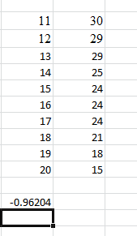 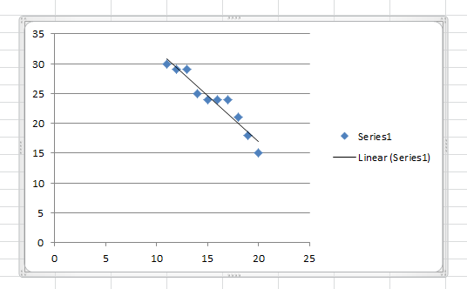

**Conclusion** –

The coefficient of correlation between price and supply is -0.96204 and has high degree of negative correlation.

----------------------------------------------------------------------------------------------------------------

**Question 5**

**Aim** - Find the correlation coefficient between the marks obtained by

ten students in economics and statistics.

|  |  |  |  |  |  |  |  |  |  |  |
| --- | --- | --- | --- | --- | --- | --- | --- | --- | --- | --- |
| Marks (in  economics | 70 | 68 | 67 | 55 | 60 | 60 | 75 | 63 | 60 | 72 |
| Marks (in  statistics | 65 | 65 | 80 | 60 | 68 | 58 | 75 | 62 | 60 | 70 |

**Procedure** –

* + 1. Draw a scatter plot along with the trend line to represent the data graphically.
    2. Place the 2 data groups adjacent to each other.
    3. Use the correl function as follows –
* Choose a blank cell and put =correl, open the bracket and enter the 2 groups of data by selecting them, close the bracket and press enter.

**Note**: If value is greater than 0.8, correlation is high. Between 0.5 and 0.8 is median and moderate. Less than 0.5, correlation is low.

**Calculations –**

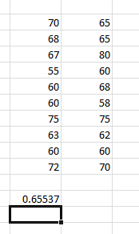 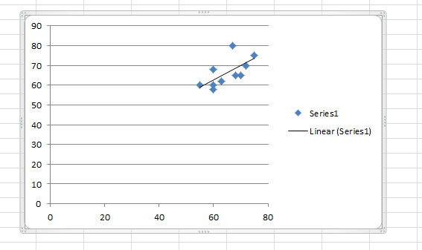

**Conclusion** –

The coefficient of correlation obtained between the marks obtained by ten students in economics and statistics is 0.65537 and has moderate degree of correlation.

----------------------------------------------------------------------------------------------------------------

**Question 6**

**Aim** - To find correlation between 2 sets of data X and Y.  
 a. Sketch a scatterplot.  
 b. Compute the correlation coefficient, r.

**Procedure** –

Draw a scatter plot along with the trend line to represent the data graphically.

Place the 2 data groups adjacent to each other.

c. Use the correl function as follows –

* Choose a blank cell and put =correl, open the bracket and enter the 2 groups of data by selecting them, close the bracket and press enter.

**Note**: If value is greater than 0.8, correlation is high. Between 0.5 and 0.8 is median and moderate. Less than 0.5, correlation is low.

**Calculations –**

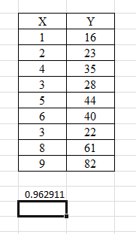 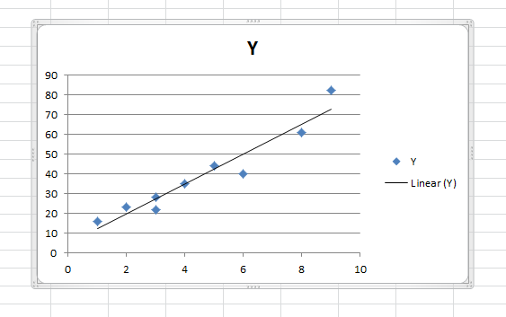

**Conclusion** –

The coefficient of correlation obtained between 2 sets of data is 0.962911 and has high degree of correlation.

----------------------------------------------------------------------------------------------------------------

THE END

--------------------------------------------------------------------------------------------